PCHRA-SHRM UPCOMING MEETINGS / EVENTS:

Wednesday, March 21st – “SIX KEY ELEMENTS OF AN EFFECTIVE TALENT ACQUISITION STRATEGY”, by Nancy Conway, SHRM Field Services Director, luncheon meeting from 11:30 a.m. – 1:00 p.m. at Maplewood Career Center. 1.25 SHRM pdc’s |Click HERE for details and registration.
Friday, APRIL 20th at THE NEW CENTER inside the NEOMED building, 2nd floor. “Conducting Internal Investigations”, breakfast and workshop by the ERC, 7:30 a.m. – Noon. Click HERE for more information and to register online. 5 SHRM professional development credits, pending HRCI credits.
Wednesday, May 16th – “The #Me Too and what we can do” presented by Bonnie Kristan, Employment Law Attorney with Littler Medelson. Hosted by Kelley Hollander and Elise DeJesus at Viking Forge Corporation from 11:30 a.m. – 1:00 p.m. 1.25 SHRM pdc’s | pending HRCI credits Click HERE for details.

Wednesday, June 6th – We will be joining the Akron Area SHRM and Stark County SHRM Chapters for a Breakfast Meeting with a presentation by Scott Warrick, JD, MLHR, CEQC, SHRM-SCP https://scottwarrick.com, CLICK HERE for details. You do not want to miss out as Scott is always informative and entertaining!
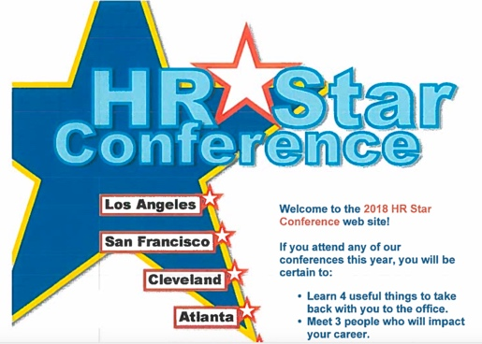
JULY - HR Star Conference – Stay Tuned for the details! We are planning to register on May 1st and possibly “carpool” (depending on # of those interested) to this annual conference in Independence, Ohio, which is FREE to the first 500 registrants. It is usually worth SIX Professional Development Credits! Click HERE for updated information.

AUGUST – “DISRUPT HR CLEVELAND” at the Music Supper Box Club – Details TBD
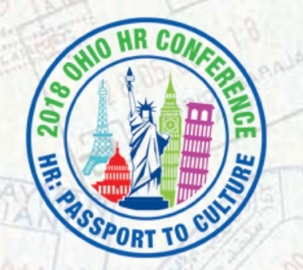
Disrupt is a night of short focused talks from professionals who want to share their ideas on how we can move our talent thinking forward. We're borrowing from the genius of Ignite, so each speaker will have 5 minutes to blow your mind! Check back HERE for updates.

SEPTEMBER – 2018 OHIO HR CONFERENCE “HR: PASSPORT TO CULTURE” held at Kalahari resort in Sandusky, Ohio on Wednesday the 19th thru Friday, the 21st Click HERE for details and registration.

